NOT AVAILABLE UNTIL LATE SEPTEMBER*

|  |  |  |
| --- | --- | --- |
| **University Supervisor**  **Quick Guide**  *Using TK20, a web-based evaluation system* |  | http://www.tk20.com/graphite/img/Tk20_ColorLogo.png |

Go to: ***corban.tk20.com***

Username: first initial, last name, ex. Kbennett. Contact Corban I.T. ([support@corban.edu](mailto:support@corban.edu)) if you are unable to log in.

Password: your Corban network password

Select the Field Experience Tab

* You will see names of student teachers you are supervising. *You will not see your student(s) for up to 3 weeks following the start of a Corban semester.
* 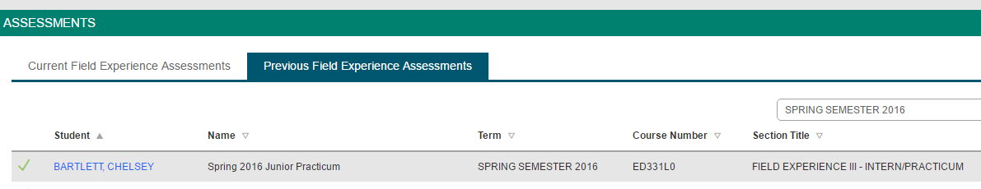Select the student you wish to record information for. Each student will have a red flag near their name until everything necessary has been submitted.

Student Name Here

* On the right hand side, you will see a number of observation or evaluation forms that you will complete. (Image below)
* For all practica complete lesson observations, edTPA submission rubric, summative evaluation and teacher dispositions.
* The number of observations and evaluations depends on the type of practicum experience. Sometimes 2 observation reports and 1 evaluation, sometimes 4 observations and a mid and summative eval, etc.

|  |  |
| --- | --- |
|  | Select form to complete.  Select **‘save’** occasionally throughout the process of completing the form.  Select **‘complete’** when form is completed.  This will take you back to the page you see to the left.  Select **‘Save’** when you have done some work or completed one or more forms, but have not completed everything.  Return to complete all forms.  Select **‘Submit’** when all forms are completed. |